Albstadt, March 22, 2010

In the Mediterranean as much as in the Carribean—your life-saver is always on board
The resuscitation device animax is your optimum life-saver at sea

Regardless of whether you own a boat, chart one or are a guest on a yacht—who wouldn’t enjoy extended cruises in turquoise waters far away from a stressful quotidian and the next harbour. This dream of secludedness can easily become a nightmare in case of an emergency. Precious time passes until a doctor is on-site. However, in case of a cardiovascular arrest the resuscitation device animax provides help within seconds. This life-saver was designed by the company AAT Alber Antrriebstechnik GmbH in Albstadt, southern Germany, by your typical ingenious Swabian inventor. What is so special about this device? The animax works without any source of energy. This independence from any external energy source makes the device the ideal mobile life-saver, particularly at sea when the next port is far away. With the animax anybody can perform cardiac massage as well as ventilation efficiently and for a long time. In addition, the device is set up and put on the patient within 20 seconds. A symmetrical frame adjusts individually to the patient’s chest size. Due to its easy handling the animax can be used by trained laypersons without problem.

The safety technology of modern boats becomes more and more complex and elaborate. By contrast the resuscitation device animax works without elaborate electronic functions altogether. With this entirely mechanical device a trained layperson can perform cardiac massage as well as ventilation over a longer period of time in an optimum fashion. Therefore the animax is particularly useful in situations when a medical doctor is not available quickly enough should someone suffer a cardiac arrest like, for instance, at sea far away from the next harbour. If there is a medical doctor aboard, he or she can take care of the patient’s medical treatment, while another person performs the resuscitation. Since the entire resuscitation is done by a revolving, smoothly working lever, one can also do this in narrow cabins and without great physical effort. In addition, one does not have to interrupt the resuscitation, while the patient is handed over to paramedics in any given harbour.

In its bag measuring 38 x 53 x 18 cm there is a pillow to tilt the head if necessary as well as a respiratory mask and a bacteria filter. Resuscitation aid plus bag weigh 14.3 kg. Since the animax works without any source of energy, it is particularly low in maintenance and causes very few follow-up costs. The way animax works is virtually self-explanatory, thus an instruction session of merely about one hour is necessary to operate the device successfully.

animax is especially conceived and designed to resuscitate adults. It was classified as a medical product class I (European Guideline 93/42/EWG) and appraised by the independent testing institute Berlin Cert.

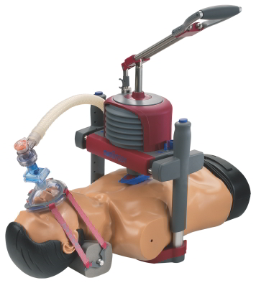

With animax the entire resuscitation is done by one lever.

Further Information:  AAT Alber Antriebstechnik GmbH  – Simone Emter  Ehestetter Weg 11 - 72458 Albstadt  Tel.: +49 74 31-12 95 117- Fax +49 74 31-12 95 35  simone@aat-online.de - www.animax-cpr.de | Press and public relations:  Press’n’Relations GmbH  – Desiree Müller  Magirusstraße 33 - 89077 Ulm  Tel.: +49 731 96287-32 - Fax: +49 731 96287-97  dmt@press-n-relations.de - www.press-n-relations.de

About AAT Alber Antriebstechnik GmbH
AAT Alber Antriebstechnik GmbH, located in the Swabian town Albstadt, was founded in 1995. Currently 65 employees work there. The enterprise has approximately 20 sales agencies in Germany as well as further agencies in over 22 countries worldwide. AAT is a traditional family enterprise that attaches great importance to the production site Germany and to their contractors producing parts and components. With their motto “development may not rest, but must progress” the central idea in all departments is to help people with a handicap. AAT is by now one of the market leaders concerning stair climbers for physically impaired persons. As for pushing aids for wheelchairs, the v-max, designed by AAT, is one of the top-selling aids in this field. In developing the animax the very first resuscitation device alternating between ventilation and cardiac massage, that works entirely mechanically, i.e. without any external source of energy, was introduced to the market. animax mono, its “little brother”, on the other hand, was designed particularly for clinical use without the ventilation unit.

