P R E S S R E L E A S E

Ulm, September 2011

"Bluesea" from the Wieland Group: copper alloy cages for better hygiene and a more sustained aquaculture

Antimicrobial effect improves conditions for fish breeding

The world's fish stocks are dropping while demand continues to climb. This basic fact is the reason why commercial fish breeding with aquaculture is growing in importance. In order to improve hygienic and production conditions at fish farms, fish cage manufacturers all over the world are working to optimize designs. One promising approach is the use of copper alloys for manufacturing the nets. The reason: the antimicrobial effect of these copper alloys keeps the nets from being overgrown by algae, barnacles and diverse parasites. In this way, copper wire cages improve oxygen circulation and the exchange of fresh water, both of which improve the health of the farmed fish. Germany's Wieland-Werke AG, as manufacturer of Bluesea copper alloys for nets, is giving a major new impetus to the use of these innovative designs. At the AquaNor Trade Show in Norway in August 2011, the company presented its range of production materials for the first time to a larger circle of professionals. At the stands of the cage manufacturer EcoSea and at the stand of the ECI European Copper Institute, Wieland presented an array of reference objects. These included very promising experiences with copper wire cages in Chile. In addition, the first cage made of Bluesea copper wire was installed in the summer of 2011 in Turkey. The design is the first copper cage in Europe put into use for trout breeding - Turkey is the second-largest trout market in Europe. A further project is currently being planned in Scotland in which it is planned to use Bluesea for the production of cages.

Results of initial practical experiences with a total of 66 copper cages in Chile have been very positive: an improvement of the feed conversion rate (FCR) of up to 15 per cent was achieved through the use of copper alloy, and the fish mortality rate was cut in half. In the process, not only was a breeding ground for diseases and infections removed, but the work of cleaning the nets could also be dramatically reduced in comparison to that with conventional cages. The longer intervals in cleaning cycles mean less stress for the fish, better uptake rates of nutrition, and less susceptibility for disease. Because copper wire networks reduce the effort of cleaning, they offer a major savings potential over the farm-type cycle and make increased fish densities possible. In addition, the sturdiness of the net is increased by the use of Bluesea copper alloy: The net retains its form even in stronger currents, offers very good protection against predators like sea lions or sharks, and effectively prevents the fish from escaping. Other advantages of the copper wire cages: they can be used not only in the sea but also in inland waters and are also 100 per cent recyclable.
The copper cage project in Turkey received scientific support from the Canakkale Onsekiz Mart University. In particular, the major challenge in designing the cages was their place of use in the Dardanelles, where two opposing currents lie one above the other and had to be taken into account. The 2 x 2 grid system is designed for a cage volume of 140 cubic metres at a depth of 50 metres in water. The chain links have a mesh opening of 30 millimetres, with a wire diameter of 2.54 millimetres. The cages are used in trout breeding, with a farm cycle from November to May.

Photo material for this Press Release is available to you for download
under www.press-n-relations.de (below the announcement there).
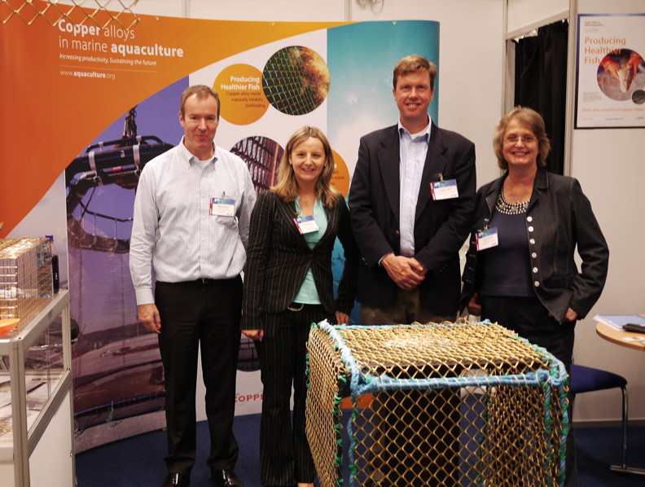
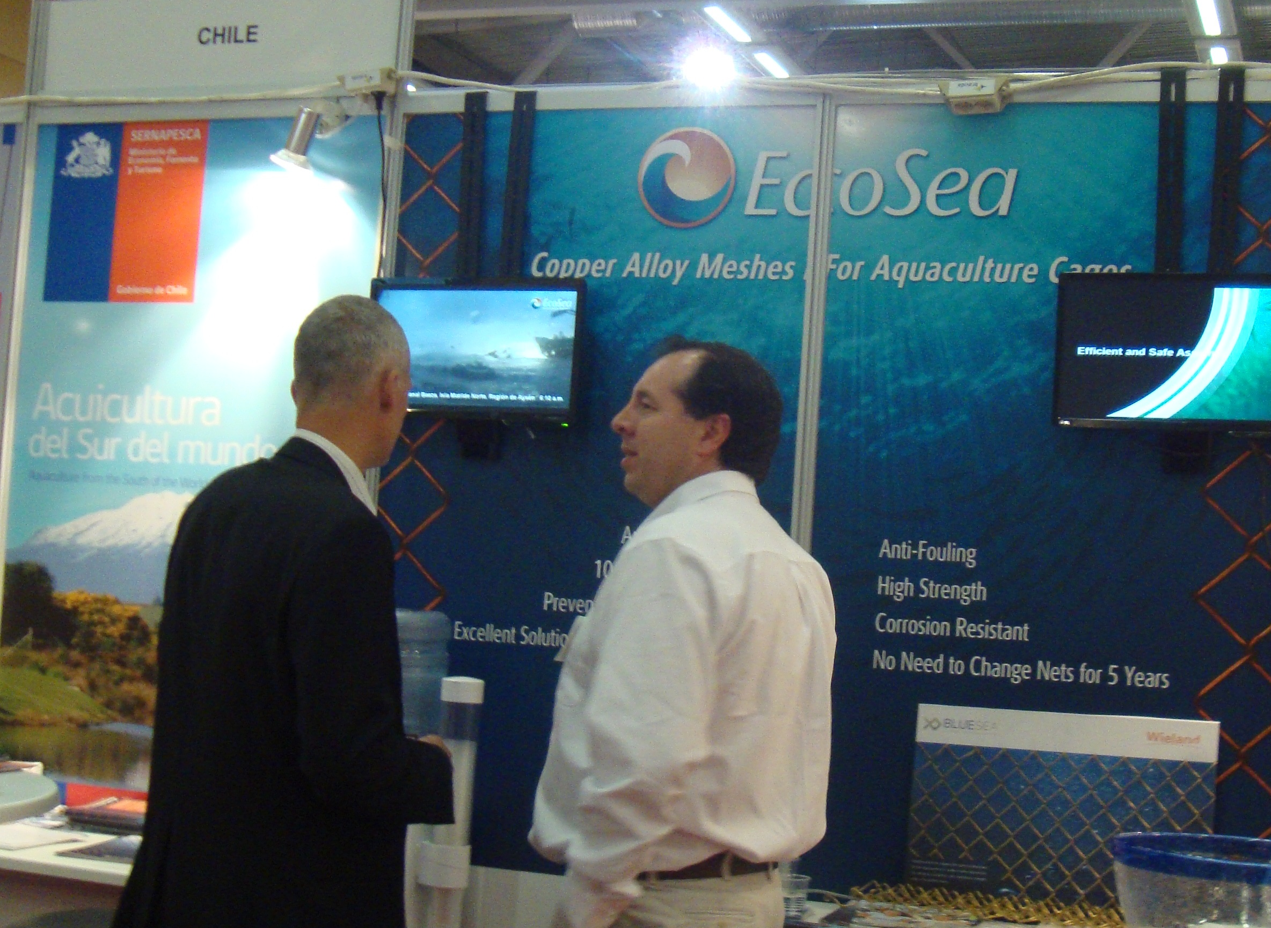

(Left:) Aquanor Trade Show team. (Right:) Interested questioners at the ECE stand.

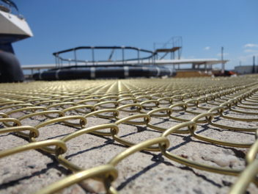
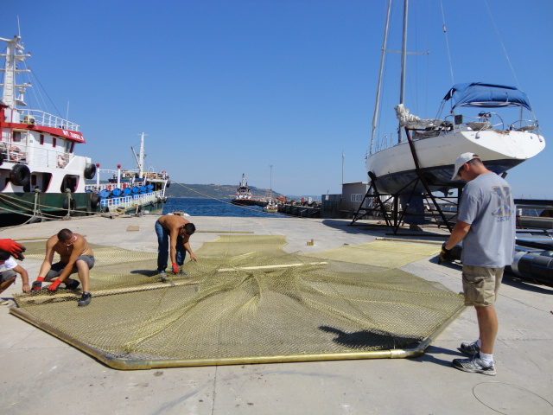

(Left:) Bluesea chain links. (Right:) Cage assembly in Turkey.
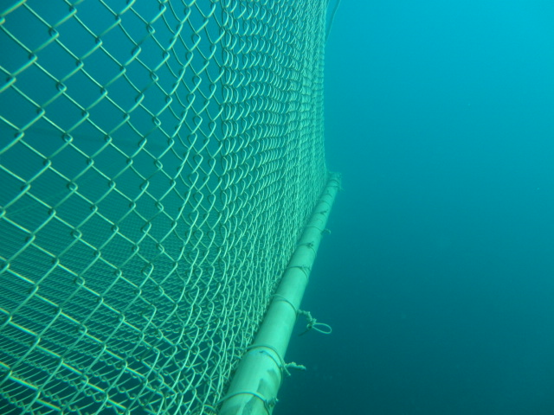
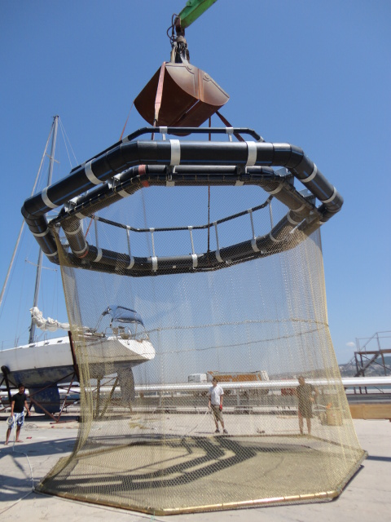

(Left:) Finished cage suspended from a crane. (Right:) In use in the sea.

Further information: Press relations:
Wieland-Werke AG  Claudia Wilhelm  Product Management Press and Draw Products  Graf-Arco-Strasse 36 - 89079 Ulm  Telephone: +49-731-944-2050  Telefax: +49-731-944-42050  claudia.wilhelm@wieland.de  www.wieland.de | Press’n’Relations GmbH  Bruno Lukas  Magirusstrasse 33 - 89077 Ulm  Telephone: +49 731-96287 17  Telefax: +49 731-96287 97  blu@press-n-relations.de  www.press-n-relations.de
Wieland-Werke AG
Karin Maier
Press Relations
Graf-Arco-Strasse 36 - 89079 Ulm
Telephone: +49 731-944-2663
Telefax: +49 731-944-42663
karin.maier@wieland.de
www.wieland.de

The Wieland Group is one of the world's leading manufacturers of semifinished goods and special products made of copper and copper alloys: bands, sheet metal, pipes, rods, wires and profiles as well as sliding elements, ribbed tubes and heat exchangers. The products, made of more than 100 different copper production materials, are used primarily in the areas of electronics and electrotechnology. Other important customer branches are the automobile industry, building construction, cooling, air conditioning and heating technology, and the machine construction and mechanical devices industry. Together with the customer, our company develops solutions for individual and industrial applications. The Wieland Group includes more than 30 production companies, metal cutting centres and trade representatives in Europe, Asia, South Africa and the USA. Among the plants of the Wieland-Werke AG are four factories in Ulm, Velbert-Langenberg, Villingen-Schwenningen and Vöhringen respectively. Wieland Brand copper tubes of the Wieland-Haustechnik Company are manufactured in Germany at the production plant in Vöhringen (Bavaria). Development, production, sales and marketing are certified in accordance with the German DIN EN ISO 9001 standard. In addition, the company has its own accredited testing and certification laboratory. The plants in Germany are certified in accordance with the international environmental DIN EN ISO 14001 standard, and the largest plant in Vöhringen is validated according to the European Environmental Auditing Standard EMAS. The sales volume of the Wieland Group in the business year 2009/2010 was 2,653 million Euros. Exports accounted for 67 per cent of this. Worldwide, Wieland employs approximately 6,500 people, more than 4,000 of these in Germany.

