
Press release
Highly flexible, Cat.6A Ethernet cable for industrial
automation applications
Nexans at the Hanover Trade Fair 2015, 13 to 17 April, hall 13, booth C45
Data transfer rate of 10 GBit/s for drag chain applications
Hanover, 13 April 2015 – The new Cat.6A cable from Nexans’ Motionline® product line transfers up to 10 GBit/s and can withstand at least 3 million bending cycles at 10 x d in the drag chain. As a result, it sets new standards for industrial Ethernet – crucial in an era of ever-increasing data volumes in industry. The new industrial Ethernet cable has been developed to meet the requirements of industry 4.0 applications such as mobile and high-resolution vision systems. The cable was tested in Nexans Deutschland GmbH’s Motion Application Centre in Nuremberg and meets all the most important international standards.
The new cable’s minimal bending radius is ten times larger than its diameter. The cable transfers signal frequencies up to 500 MHz and offers an impressive reduction in crosstalk and system noise. It can also withstand recurring, sharp movement. To protect people and equipment in the event of a fire, the PUR cable sheath is halogen-free but also abrasion-proof and oil-resistant.
“We are proud to present the new Cat.6A cable, a product that reliably meets the challenge of transferring ever-increasing volumes of data in industry, even when subjected to constant movement and exposed to the harshest environmental conditions,” says Philipp Teepe, Marketing Manager Automation at Nexans. “Nexans will continue to offer innovative solutions aimed at supporting the further development of the automation industry.
(approx. 1,500 characters)

Figure: large_150414[1].jpg
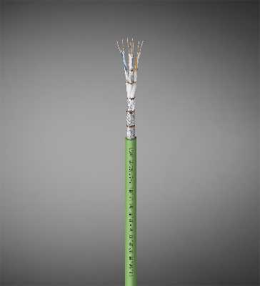
The new Cat-6A line reliably meets the industry requirement of transferring large volumes of data without faults, even when subjected to constant movement and exposed to the harshest of ambient conditions.

Nexans Germany
Nexans Germany is one of the leading cable manufacturers in Europe. The company is offering an extensive range of high performance cables, systems, and components for the telecommunications and energy sectors, rounded off by superconducting materials and components, Cryoflex transfer systems and special machinery for the cable industry. Producing at manufacturing plants with approx. 10,215 employees in Germany and abroad, the sales in 2014 amounts to approx. 933 Mio Euro. The full integration into the Nexans Group Nexans Germany also benefits from excellent opportunities to use the available synergies in all corporate fields, which not only applies to worldwide projects but also to research and development, the exchange of Know how, and to other areas.
More information on www.nexans.de

Press Contact

Nexans Deutschland GmbH
Jutta van Buehl
Kabelkamp 20
30179 Hanover (Germany)
Phone: +49 (0)511 676-2629
Fax: +49 (0)511 676-2480
Mail: Jutta.van_Buehl@nexans.com
Website: www.nexans.de
Press’n’Relations II GmbH
Ralf Dunker
Graefstrasse 66
81241 Munich
Phone: +49 (0)89 5404722-11
Fax: +49 (0)89 5404722-29
Mail: du@press-n-relations.de
Website: www.press-n-relations.d

