
Press release
Temporary site cables: reducing disconnecting times
Nexans at the Hanover Trade Fair 2015, 13 to 17 April, hall 13, booth C45
Robust and easy-to-handle cable solution for temporary use in the high-voltage network
Hanover, 13 April 2015 – Temporary site cables are custom-made, quick-connectable cables for use in the high-voltage network, for example, in conversions on overhead lines or transformer stations. They feature multi-strand copper conductors with cross-sections of 150 mm2 and 300 mm2 and have a similar design to high voltage cables. High-purity insulation material allows a reduced insulation thickness, which results in a compact cable with reduced outer diameter and weight. Temporary site cables are pre-installed with flexible pre-fabricated and pre-tested silicone rubber terminations. Thanks to these features, temporary site cables are easy to handle on construction sites and quick to connect.
The cables are available for 110, 132, 150 or 230 kV and are usually produced in lengths of 50 m to 500 m. They are delivered on highly durable single- or triple-chamber drums that ensure safe unwinding and winding of the cables and the pre-fabricated terminations. Prior to delivery, each individual cable is routine tested in the high-voltage laboratory. Since the temporary site cables are exceptionally robust, they do not have to be checked for freedom from partial discharge until they have been used a number of times. To increase the current-carrying capacity of around 750 A, temporary site cables can also be connected in parallel.
Temporary site cables are not only suitable for the temporary supply of power during scheduled conversion work in transformer stations or as an alternative to temporary installation overhead lines. They can also be put to instant use in case of emergencies or disruptions such as storm damages. Nexans’ innovative temporary site cables help to ensure a secure power supply at any time.
(approx. 1,800 characters)

Picture: large_Baueinsatzkabel_IMG_1333[1].jpg:
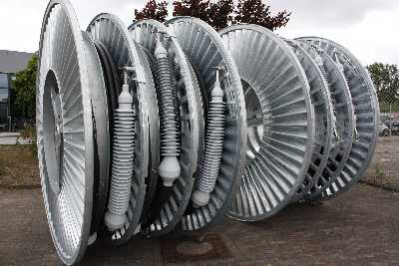
Nexans’ innovative temporary site cables help to ensure a secure power supply, because they can be put to instant use as a tested and reliable piece of operating equipment, whatever the weather.
Nexans Germany
Nexans Germany is one of the leading cable manufacturers in Europe. The company is offering an extensive range of high performance cables, systems, and components for the telecommunications and energy sectors, rounded off by superconducting materials and components, Cryoflex transfer systems and special machinery for the cable industry. Producing at manufacturing plants with approx. 10,215 employees in Germany and abroad, the sales in 2014 amounts to approx. 933 Mio Euro. The full integration into the Nexans Group Nexans Germany also benefits from excellent opportunities to use the available synergies in all corporate fields, which not only applies to worldwide projects but also to research and development, the exchange of Know how, and to other areas. More information on www.nexans.de

Press Contact

Nexans Deutschland GmbH
Jutta van Buehl
Kabelkamp 20
30179 Hanover (Germany)
Phone: +49 (0)511 676-2629
Fax: +49 (0)511 676-2480
Mail: Jutta.van_Buehl@nexans.com
Website: www.nexans.de
Press’n’Relations II GmbH
Ralf Dunker
Graefstrasse 66
81241 Munich
Phone: +49 (0)89 5404722-11
Fax: +49 (0)89 5404722-29
Mail: du@press-n-relations.de
Website: www.press-n-relations.de

