
Press release
Connection elements: robust and easy to install
Nexans at the Hanover Trade Fair 2015, 13 to 17 April, hall 13, booth C45
Robust and easy-to-use installation accessories
Hanover, 13 April 2015 – Not only does Nexans have expertise in cables of all types, it is also a specialist in connection technology and power cable fittings. At the Hanover Trade Fair, Nexans will present its new range of 66 kV fittings, large mechanical connectors for medium-voltage applications, a new low-voltage mechanical cable lug and fittings for smart grids.
The new GPH M800-1200
With the GPH M800-1200 bolted connector, Nexans is expanding its successful range of connectors and mechanical cable lugs to include a component ideally suited for connecting onshore and offshore wind farms to medium-voltage grids. The GPH M800-1200 bolted connector was designed as a durable connection between copper and aluminium conductors in the cross-section range from 800 to 1,200 mm² and can be installed quickly and securely using commercially available hexagon head and socket tools. Its patented GPH shear-off bolts holds the conductor in the connector with optimum contact force at all times. Like all bolted technology products from Nexans Power Accessories Germany, this connector is also inspected in accordance with IEC standard 61238-1, Class A.

New fittings for wind energy applications
The R909TB/G tee connector (connection type F) is a separable cable connection for connecting plastic-insulated high-voltage cables to transformers or switching stations. It is encased in a thick-walled conductive layer made from EPDM. A sheath fault test can be performed on the cable while the fitting is attached.
The R909PB/G coupling connector is a separable cable connection designed for multiple plug requirements and is used together with the R909TB/G tee connector. The multiple plug arrangement can be expanded by any number of coupling connectors. Here, too, the sheath fault test can be performed on the cable while the fitting is attached.
The right overvoltage arrester for the R909TB/G tee connector is 900SA-CD and was developed for grids of up to 72.5 kV, just like the two connector types. It protects high-voltage components such as power and load switching stations or transformers as well as cable networks from damage caused by overvoltages induced by lightning or switching voltage surges.
Covering the entire cross-section range, the AFN72 silicone slide-on terminal for outdoor and indoor applications connects plastic-insulated high-voltage cables to overhead lines or bus bars. Thanks to its compact, modular design, it compensates for various environmental influences in indoor and outdoor applications.

New D-Series mechanical cable lug
For low-voltage applications, Nexans has kitted out its GPH D-Series with new GPH connection technology offering all of the key design features of the D-Series connectors: the fully tin galvanised bolted cable lugs of the D-Series allow copper and aluminium conductors of all types and with cross-sections from 1.5 mm² to 240 mm² to be connected. The patented GPH bolted technology compensates for conductor tolerances while ensuring optimum contact force at all times. A special conductor channel enables the sector conductors (se and sm), generally of at least 35 mm² in size, to be contacted without prior mechanical conductor reforming. The basic design of the D-Series is inspected in accordance with medium-voltage standard IEC 61236-1, Class A, and offers maximum connection quality and service life for the user.
(approx. 3,500 characters)

Picture: AFN72.jpg
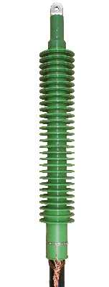
Silicone-Slip-On termination AFN72
Picture: R909PB_G.jpg
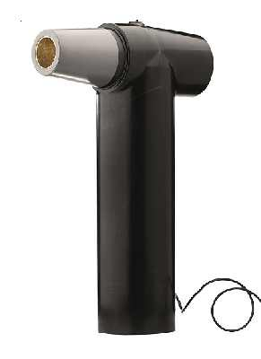
Coupling connector R909PB/G

Picture: R909TB_G.jpg
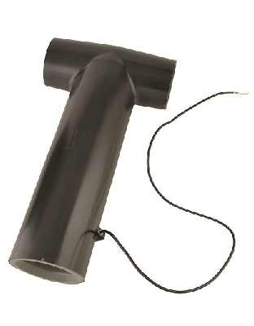
T-connector R909TB/G (Interface F)
Picture: 900SA-CD.jpg
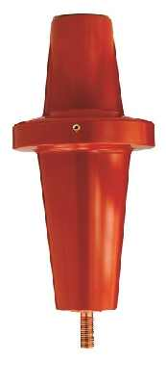
The surge arrester for R909TB/G T-connector is 900SA-CD

Picture: M800-1200_ schatten_frei.jpg
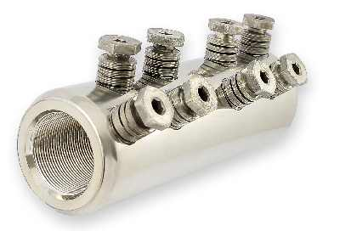
GPH M800-1200 bolted connector
Picture: D series conductor combinations_mit kabelschuh_neu.jpg
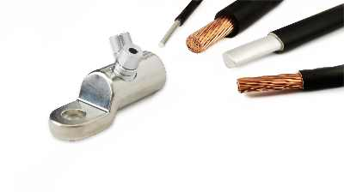
Mechanical cable lug of GPH D-Series

Nexans Germany
Nexans Germany is one of the leading cable manufacturers in Europe. The company is offering an extensive range of high performance cables, systems, and components for the telecommunications and energy sectors, rounded off by superconducting materials and components, Cryoflex transfer systems and special machinery for the cable industry. Producing at manufacturing plants with approx. 10,215 employees in Germany and abroad, the sales in 2014 amounts to approx. 933 Mio Euro. The full integration into the Nexans Group Nexans Germany also benefits from excellent opportunities to use the available synergies in all corporate fields, which not only applies to worldwide projects but also to research and development, the exchange of Know how, and to other areas. More information on www.nexans.de

Press Contact

Nexans Deutschland GmbH
Jutta van Buehl
Kabelkamp 20
30179 Hanover (Germany)
Phone: +49 (0)511 676-2629
Fax: +49 (0)511 676-2480
Mail: Jutta.van_Buehl@nexans.com
Website: www.nexans.de
Press’n’Relations II GmbH
Ralf Dunker
Graefstrasse 66
81241 Munich
Phone: +49 (0)89 5404722-11
Fax: +49 (0)89 5404722-29
Mail: du@press-n-relations.de
Website: www.press-n-relations.de

