Neutal, Sept. 28, 2015

FT-TEC Electronics at the hanseboot, 31 October – 8 November 2015, hall B3/GF, stand B.123

World first: FT-TEC presents first PLB/AIS combined emergency device

SEAANGEL SA16+ transmits distress signal via AIS and satellite – even quicker location of people in distress at sea

The Austrian electronics specialist FT-TEC Electronics presents a worldwide unique combined emergency device on the hanseboot 2015. The SEAANGEL SA16+ is a compact, water-tight and floatable search and rescue device with integrated location technology. For the first time, the device transmits on two international rescue channels, i.e. on AIS frequencies and the satellite system Cospas Sarsat. This enables an even faster and more precise location of people in distress at sea. SEAANGEL SA16+ can be used by professional seamen as well as recreational boaters. In addition, FT-TEC Electronics presents the extra-compact AIS FLARE. Like the bigger SEEANGEL models, the small emergency transmitter that is only 62 x 41 x 29 mm big reaches a range of up to ten sea miles and can be integrated especially easily in life vests. "We considerably further developed the SEAANGEL product range with regard to performance as well as to design. All our emergency devices comply with the international safety standards of professional seafaring and are made in Austria. In that way, we ensure the highest quality and reliability of our systems", explains Friedrich Trobolowitsch, CEO of FT-TEC Electronics.

In the scope of the hanseboot 2015, the Austrian specialist FT-TEC Electronics presents a total of five product groups with emergency transmitters and receivers. At fair stand B.123, you can see in addition to the world first SEAANGEL SA16+, the SEAANGEL SA14 SART too – a professional, SOLAS-certified location device for professional seafaring that transmits a distress signal with up to two Watts via AIS frequencies over up to ten sea miles and for 96 hours. The distress signal is put out by simply pressing a button on the device or automatically by self-timer or rip cord. Each ship equipped with AIS, but also AIS stations on shore or search and rescue aircraft at a distance of up to ten sea miles can receive the accident victim's GPS position and initiate pinpoint salvage. The integrated lithium-manganese-dioxide batteries with a life of five years and the range of application from minus 20 to plus 55 degrees ensure a high degree of reliability. The scope of delivery of the compact device that weighs only 190 grams and measures 138 x 65 x 25 mm (RRP 532.50 Euro excl. VAT) comprises a multi-purpose assembly kit and the telescopic rod that is prescribed by the standard and enables the transmission of signals by radio one meter above the water.

Professional location systems for recreational captains as well
Especially for sailors, motor yachtsmen or water sportsmen, FT-TEC Electronics further developed the more budget-priced variant of the member-over-board system. Now the SEAANGEL SA14 MOB transmits an AIS distress signal with a range of up to ten sea miles for at least 72 hours with a battery life of seven years. The device is available for 282.50 Euro (excl. VAT). The AIS FLARE that was developed completely new is the first miniature emergency transmitter that complies with the EU wide MOB standards. It also uses the AIS frequencies, enables a range of up to ten sea miles and transmits for at least 36 hours at minus 20 degrees. It is set up with the rip cord or manually. The emergency tool will be available from 2016 for 207.50 Euro (excl. VAT). "With the AIS FLARE, we packed up our verified location technology for the first time in a compact and budget-priced device that can be integrated particularly easily in life vests, marking buoys, life rafts and life belts", so Friedrich Trobolowitsch.

SEANEXX RX receiver in USB format
In order to complete its product range, FT-TEC offers the SEANEXX RX receivers for the AIS distress signal. The small USB module receives on two channels and in the GNSS standard and enables the precise location of the person seeking help by visualizing the position data on a laptop, PC, tablet or smartphone. SEANEXX RX works with Microsoft Windows, Linux, Android or IOS operating systems and can transmit to up to ten devices at the same time. Handy accessory equipment such as antennas and adapter cables complement the system. SEANEXX RX is available in two different versions from 115.83 Euro (excl. VAT). "We constantly keep developing our recreational location systems in order to make the devices even smaller, handier and more user-friendly", so Friedrich Trobolowitsch.

Quick help thanks to AIS
According to WHO report, drowning is the second most common cause of death after traffic accidents. Most water-related accidents happen close to shore and next to boats. This is why the communication system AIS was established by the International Maritime Organization (IMO) in the year 2000. The search and rescue system SEAANGEL uses the AIS standard and considerably increases the chance of survival. When the AIS distress signal is activated, SEAANGEL transmits the current GPS data of the accident victim via radio at one-minute intervals. On the frequencies 161,975 and 162,025 megahertz, rescuers who are in the vicinity and equipped with an AIS system can receive the distress call. The AIS-enabled receiver shows a crossed-out circle as an emergency symbol. The distress signal that is constantly transmitted enables the exact tracking of the accident victim's position and a fast start of salvage, explains Friedrich Trobolowitsch.

www.seaangel.at

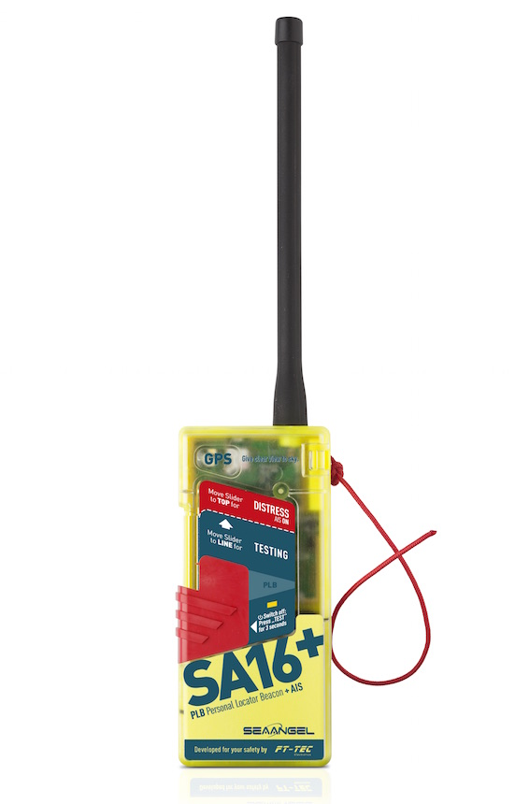
World first: SEAANGEL SA16+ transmits distress signal via AIS and satellite
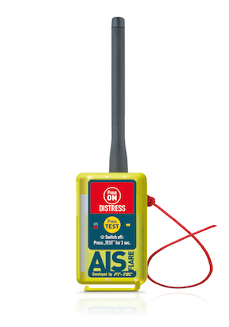
AIS FLARE: first miniature emergency transmitter that complies with the EU-wide MOB standards

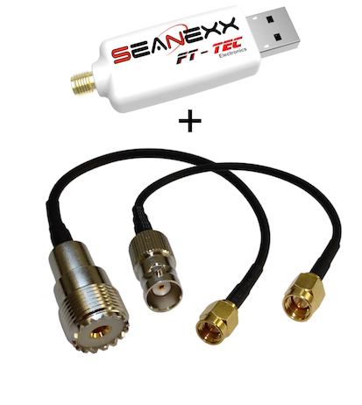
The SEANEXX receiver enables precise location by visualization of the positional data


Friedrich Trobolowitsch, CEO FT-TEC Electronics

Photo material to download is available on our media platform AMID-PR (search term "FT-TEC SEAANGEL").

More information:  FT-TEC Electronics GmbH  Andreas Krejci – sales manager  Werner von Siemens-Straße 5 – A-7343 Neutal  Phone: +43 2618 20 455 4020 – Fax: +43 2618 20 455 9010  a.krejci@ft-tec.com – www.ft-tec.com | Press and public relations:  Press'n'Relations Austria GmbH  Georg Dutzi  Währinger Straße 61 – A-1090 Vienna  Phone: +43 1 907 61 48-10  gd@press-n-relations.at – www.press-n-relations.com

About FT-TEC Electronics
FT-TEC Electronics with headquarters in Neutal/Austria was founded in 2014 and is part of the FT-TEC Group. The company develops and produces innovative emergency systems for professional seamen and recreational boaters. The quality products exclusively manufactured in Austria are exported world-wide.
FT-TEC was founded by Friedrich Trobolowitsch in 2005 and is a privately owned company. Since 2014, FT-TEC Holding has combined three companies – FT-TEC Electronics, FT-TEC Production and FT-TEC Trading – under one umbrella. The subsidiaries offer highly specialized products from the plastic, elastomer and electronics industries. Their clients comprise companies from the railway and transponder industries and the automotive industry.

