Ulm, November 2008

KAMAG delivers two gigantic platform elevating trucks to Chinese shipyard
Total combined weight of 144 tonnes and can carry more than 750 tonnes

Each of the two special vehicles has the surface area of a comfortably-sized single family house and, together, could lift the weight of around 560 medium range cars. The truck is more manoeuvrable than a passenger car and can even turn on its own axle. Both of these heavy transporters have been developed and prioduced by the Ulm-based special vehicle manufacturer KAMAG Transporttechnik.

The two gigantic platform elevating trucks were delivered to the Chinese customer after an approximate six-month construction period. Shanghai is the final place of destination, a journey totalling 9,000 kilometres.This is the location of one of the largest shipyards in the world and it is here that the two special vehicles will used to transport large ship components. Modern shipbuilding is based on the sectional constructional method by which individual sections of the vessel are produced at different places in the yard. The complete ship is then formed by joining the individual sections together.

These special platform elevating trucks have been designed to carry out this task. In order that they can accommodate the load, lifting cylinders have been integrated in the individual pendulum axle wheel sets. After the transporter is driven under the load, which is supported on blocks, it raises this by means of the lifting cylinders. The hydraulic system is fed by a diesel engine that drives the hydraulic pumps which, in turn, supplies the pressure oil for the lifting procedure. The hydraulic motors installed in the wheel sets are also oil-driven. The advantage of this hydrostatic drive: it functions for both driving directions so that all movement is extremely smooth and jerk-free as well as having a very sensitive regulating control feature. This is particularly important when the ship sections are being placed in their assembly positions. The whole process is carried out with great precision so that the individual sections are positioned and joined together with millimetre accuracy. The high degree of manoeuvrability is supported by the electronic multi-directional steering. With this, the transporter is able to perform circular, transversal and diagonal driving operations. The platform elevating truck can even turn on its own center-point. As space is mostly at a premium in shipyards, the manoeuvrability of large vehicles is of crucial importance.

Only with such special vehicles can those challenging transportation tasks found in shipyard logistics be carried out professionally and cost-effectively. KAMAG Transporttechnik has been a recognised global supplier for almost 40 years in the shipbuilding industry as well as other industrial sectors. Thus, special vehicles from KAMAG reliably tackle a wide range of transportation tasks around the world on a daily basis – with great success.

Overview of the technical details:

6-axle platform elevating truck -Type 1406S HS 4 E

No. of axle lines: 6
Platform length: approx. 18,000 mm
Platform width: approx. 7,000 mm
Payload: approx. 325,000 kg
Tare weight: approx. 59,000 kg
Total weight: approx. 384,000 kg
No. of wheels: 48
Inner turning radius: 0 mm
Outer turning radius: approx. 11,350 mm
Engine: Deutz diesel engine Type BF 6 M 1015 C
Performance: 286 kW / 389 PS

8-axle platform elevating truck - Type 1408S HS 5 E

No. of axle lines: 8
Platform length: approx. 21,000 mm
Platform width: approx. 7,000 mm
Payload: approx. 427,000 kg
Tare weight: approx. 85,000 kg
Total weight: approx. 512,000 kg
No. of wheels: 64
Inner turning radius: 0 mm
Outer turning radius: approx. 12,000 mm
Engine: Deutz diesel engine Type BF 8 M 1015 C
Performance: 381 kW / 518 PS

Photo:
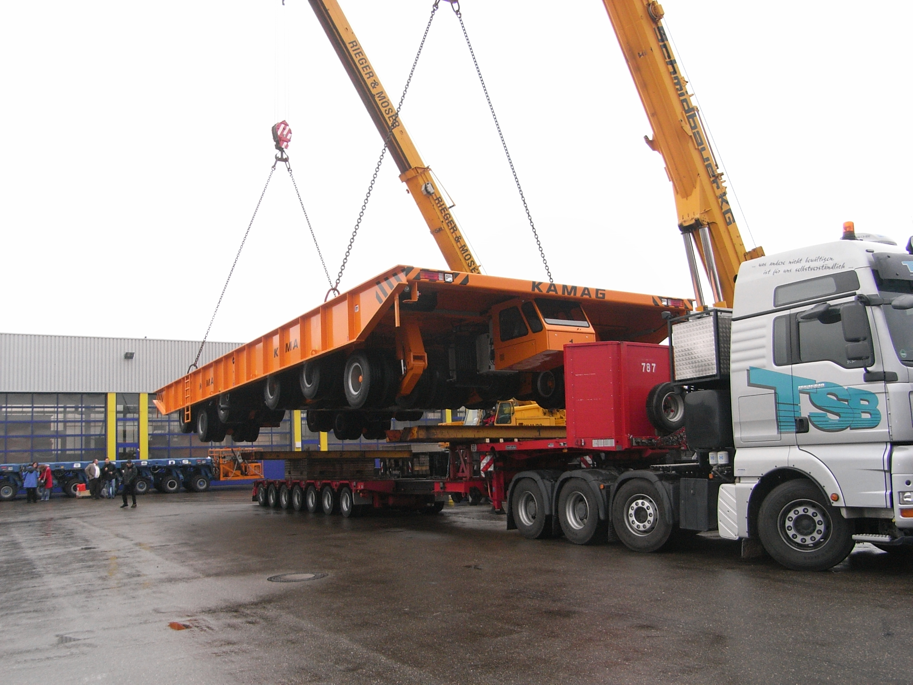

The 6-axle platform elevating truck – Type 1406S HS 4 E - during loading operations at the KAMAG plant

Photos to accompany this press release can be downloaded from www.press-n-relations.de.

More Information:
KAMAG Transporttechnik GmbH & Co. KG
Liststraße 3
89079 UIm / Germany
Tel.: +49 (0)731 409 80
Fax +49 (0)731 409 8109
info@kamag.com
www.kamag.com

Press Office:
Yource GmbH - Lothar Riesenegger
Magirusstraße 33
89077 Ulm / Germany
Tel.: +49 (0)731 962 8782
Mobile +49 (0)171 873 0916
lothar.riesenegger@yource.de
www.yource.de

Information on KAMAG Transporttechnik
Transporters from KAMAG are recognised across the world for their advanced technology and special product quality. Reliability in daily use, high load capacity and a long working life make the vehicles a very important component of modern logistical operations. The history of vehicle technology for heavy transport vehicles is closely connected with the name of KAMAG The company belongs to the group of firms of Heilbronn industrialist Otto Rettenmaier. Within the group, the "TII – Transporter Industry International" heavy-load division is global market leader.

