Neutal, October 13, 2015

FT-TEC Electronics at the METSTRADE, Nov. 17.-19. 2015, hall 5, stand 5.304

World first: FT-TEC presents first PLB/AIS combined emergency device

SEAANGEL SA16+ transmits distress signal via AIS and satellite – even quicker location of people in distress at sea

The Austrian electronics specialist FT-TEC Electronics presents a worldwide unique combined emergency device at METSTRADE 2015. SEAANGEL SA16+ is a rugged, water-tight and floatable emergency beacon with geolocation technology and designed for integration in life vests. For the first time, the device transmits on two international rescue channels, i.e. on AIS frequencies and the satellite system Cospas Sarsat. This guarantees more reliability that the alert is recognized indepent if the emergency situation happens close to shore or offshore. SEAANGEL SA16+ can be used by professional seamen as well as recreational boaters. In addition FT-TEC Electronics shows AIS FLARE, the worlds smallest emergency AIS MOB device. The extra compact emergency transmitter is only 62 x 41 x 29 mm and can be integrated easily in life vests. The AIS FLARE transmits for minimum of 36 hour and alerts stations up to 10 nautical miles. Brand new is also SEANEXX DATA SERVER. The device combines GPS, AIS Receiver and Multiplexer. It receives AIS signals, GPS position and traditional NMEA instrument data and transmits the data via WiFi onboard to up to 10 clients. The combined data can be also transmitted via conventional NMEA or USB. For charter sailing and all sailors without an own yacht, MOBILE AIS is the battery powered AIS receiver, USB stick designed solution. The battery pack allows 20 hours of independent operation. The AIS data is transmitted wireless via WiFi. “We considerably further developed the SEAANGEL product range with regard to performance as well as design. All our products are developed and manufactured in Austria. This guarantees for highest quality and reliability of our systems", explains Friedrich Trobolowitsch, CEO of FT-TEC Electronics.

In the scope of the METS 2015, the Austrian specialist FT-TEC Electronics presents a total of five product groups with emergency transmitters and receivers. At fair stand 5.304, hall 5 you can see in addition to the world first SEAANGEL SA16+, the SEAANGEL SA14 SART too – a professional, SOLAS-certified location device for professional seafaring that transmits a distress signal with up to two Watts via AIS frequencies over up to ten sea miles and for 96 hours. The distress signal is put out by simply pressing a button on the device or automatically by self-timer or rip cord. Each ship equipped with AIS, but also AIS stations on shore or search and rescue aircraft at a distance of up to ten sea miles can receive the accident victim's GPS position and initiate pinpoint salvage. The integrated lithium-manganese-dioxide batteries with a life of five years and the range of application from minus 20 to plus 55 degrees ensure a high degree of reliability. The scope of delivery of the compact device, that weighs only 190 grams and measures 138 x 65 x 25 mm (RRP 532.50 Euro excl. VAT), comprises a multi-purpose assembly kit and the telescopic rod that is prescribed by the standard and enables the transmission of signals by radio one meter above water level.

Professional location systems for recreational captains as well
Especially for sailors, motor yachtsmen or water sportsmen, FT-TEC Electronics further developed the more budget-priced variant of the member-over-board system. Now the SEAANGEL SA14 MOB transmits an AIS distress signal with a range of up to ten sea miles for at least 72 hours with a battery life of seven years. The device is available starting from 282.50 Euro (excl. VAT). The AIS FLARE that was developed completely new is the first miniature emergency transmitter that complies with the EU wide MOB standards. It also uses the AIS frequencies, enables a range of up to ten sea miles and transmits for at least 36 hours at minus 20 degrees. It is set up with the rip cord or manually. The emergency tool will be available from 2016 starting from 207.50 Euro (excl. VAT). "With the AIS FLARE, we packed up our verified location technology for the first time in a compact and budget-priced device that can be integrated particularly easily in life vests, marking buoys, life rafts", says Friedrich Trobolowitsch.

SEANEXX – innovative AIS receivers and Smart Navigation Electronics
FT-TEC Electronics also offers an expanded range of SEANEXX AIS receivers and data appliances. MOBILE AIS is a battery powered Dual Channel AIS receiver with wireless connectivity via WiFi. The battery allows 20 hours of independent usage and offers a integrated LED torch. The compact SEANEXX AIS USB stick is a full Dual Channel AIS receiver in the size of a commercially available USB stick. It plugs into USB port on laptop/PC and is compatible to computer based Navigation software like OpenCPN. It is available as a set with clip-antenna, which is easily placed without assembly. The SEANEXX DATA SERVER combines AIS, GPS receiver and NMEA multiplexer functionality in one unit. AIS information, GPS position data is combined with the NMEA instrument data (i.e. depth, speed, wind speed) and converted into one data stream which can be transmitted wireless via WiFi to up to ten clients (iPad, Tablet, Smartphone, Laptop, WiFi enabled Plotter) simultaneously or conventionally via NMEA or USB. The data logger stores processed data on an SD-card. The package with the combo senor Triducer from Airmar (depth, speed, temperature) is designed to be used with iPad, Android or Windows Tablets. The SEANEXX DATA SERVER is fully compatible to any NMEA0183 sensor. The SEANEXX AIS RECEIVER contains a Dual Channel AIS receiver and an integrated 72 channel GPS receiver. This AIS/GPS combo receiver is able to transmit the data wireless via WiFi to up to 10 clients simultaneously or conventional via NMEA0183 to a plotter or USB to a laptop. The receiver is available as AIS-receiver only or AIS/GPS combo receiver. “We improve our products continuously to deliver the best and most user friendly products”, says Friedrich Trobolowitsch, CEO FT-TEC Electronics.

Quick help thanks to AIS
According to WHO report, drowning is the second most common cause of death after traffic accidents. Most water-related accidents happen close to shore and next to boats. This is why the communication system AIS was established by the International Maritime Organization (IMO) in the year 2000. The search and rescue system SEAANGEL uses the AIS standard and considerably increases the chance of survival. When the AIS distress signal is activated, SEAANGEL transmits the current GPS data of the accident victim via radio at one-minute intervals. On the frequencies 161,975 and 162,025 megahertz, rescuers who are in the vicinity and equipped with an AIS system can receive the distress call. The AIS-enabled receiver shows a crossed-out circle as an emergency symbol. The distress signal that is constantly transmitted enables the exact tracking of the accident victim's position and a fast start of salvage, explains Friedrich Trobolowitsch.

www.seaangel.at

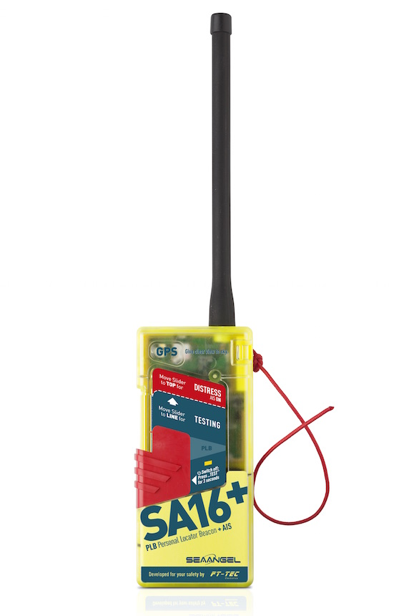
World first: SEAANGEL SA16+ transmits distress signal via AIS and satellite
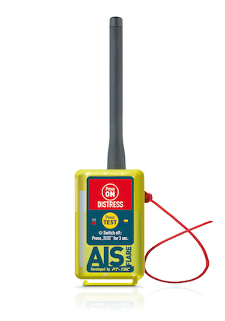
AIS FLARE: first miniature emergency transmitter that complies with the EU-wide MOB standards

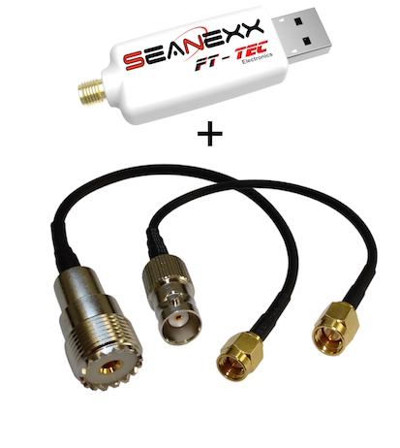
The SEANEXX receiver enables precise location by visualization of the positional data with extension to WiFi system as called MOBILE AIS
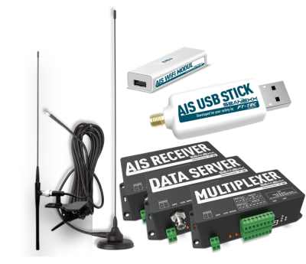
The SEANEXX RX series as data receiver, data server or multiplexer


Friedrich Trobolowitsch, CEO FT-TEC Electronics

Photo material to download is available on our media platform AMID-PR (search term "FT-TEC SEAANGEL").

More information:  FT-TEC Electronics GmbH  Andreas Krejci – sales manager  Werner von Siemens-Straße 5 – A-7343 Neutal  Phone: +43 2618 20 455 4020 – Fax: +43 2618 20 455 9010  a.krejci@ft-tec.com – www.ft-tec.com | Press and public relations:  Press'n'Relations Austria GmbH  Georg Dutzi  Währinger Straße 61 – A-1090 Vienna  Phone: +43 1 907 61 48-10  gd@press-n-relations.at – www.press-n-relations.com

About FT-TEC Electronics
FT-TEC Electronics with headquarters in Neutal/Austria was founded in 2014 and is part of the FT-TEC Group. The company develops and produces innovative emergency systems for professional seamen and recreational boaters. The quality products exclusively designed and manufactured in Austria are exported world-wide.
FT-TEC was founded by Friedrich Trobolowitsch in 2005 and is a privately owned company. Since 2014, FT-TEC Holding combines three companies – FT-TEC Electronics, FT-TEC Production and FT-TEC Trading – under one umbrella. The subsidiaries offer highly specialized products from the plastic, elastomer and electronics industries. Their clients comprise companies from the railway, transponder and the automotive industry.

