Wieland-Werke AG
Graf-Arco-Str. 36
89079 Ulm

Ulm, 22 February 2017

Ingersoll Rand | Trane grants the Wieland Group its
2016 Innovation & Value Creation Award

Charlotte, US. As one of six laureates, the Wieland Group was selected out of 13,000 suppliers by Ingersoll Rand for its 2016 Innovation & Value Creation Award.
Proposed by the Trane leadership for Technical Tubes in North America, the award is an appreciation of the close collaboration with R&D for technical innovations, as well as of the high quality and delivery performance for technical and industrial tubes on a global level. Criteria for this award included the delivery of innovative, customer-driven solutions, the expansion into emerging markets and the increase of the service business to drive profitable growth.

In 2016, Wieland Thermal Solutions in particular had risen to the occasion and partnered with Ingersoll Rand to help deliver an innovative solution to customers, creating mutual success for both companies. Especially in the HVAC Chiller business, Wieland Thermal Solutions was recognized for continued effort to work hand in hand with Ingersoll Rand Engineering to develop new products to meet a defined customer niche. The award finally honors the willingness consistently demonstrated to invest in the development of innovative products. Wieland Thermal Solutions has a track record for meeting the high expectations for quality and delivery, while launching new product developments into production.

About Wieland

The Wieland Group, with headquarters in Ulm, Germany, is one of the world's leading manufacturers of semi-finished products in copper and copper alloys, such as strip, sheet, tubes, rods, wires and sections. Wieland also manufactures finned tubes and heat exchangers, slide bearings and system components. Besides copper
and copper alloys, Wieland also uses other metallic materials such
as aluminium, steel, stainless steel and titanium.
As an international company, Wieland has manufacturing companies, slitting centres and trading companies in many European countries as well as in the USA, in South Africa, Singapore, China and India. The Wieland Group employs some 6,800 people worldwide, 4,400 of them in Germany.
Wieland Thermal Solutions develops and manufactures high-performance tubes and heat exchangers for optimum thermal output using minimal material and energy. Applications for these products are found in the air conditioning, refrigeration and heating industry as well as in process, machinery and plant technology.

Reader enquiries

Wieland-Werke AG | Thermal Solutions
Barbara Schüßler
Global Marketing Manager
Phone: +49 (0)731 944-2147
barbara.schuessler@wieland.de
www.wieland-thermalsolutions.com

Wieland-Werke AG | Corporate Communications
Karsten Mahr
Graf-Arco-Straße 36 - 89079 Ulm
Phone: +49 (0)731 944-2451
karsten.mahr@wieland.de
www.wieland.com

Picture
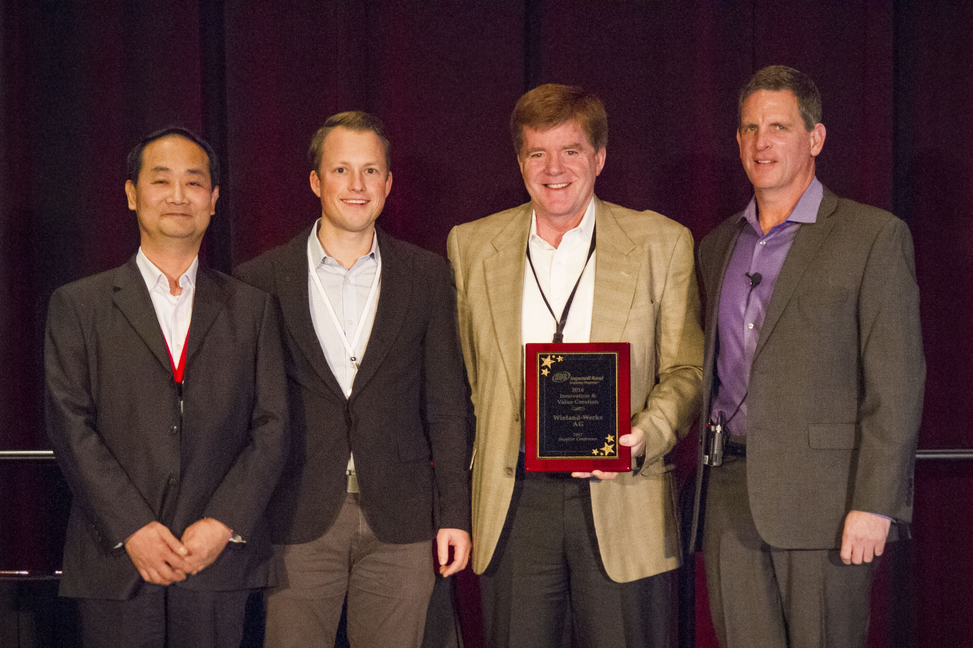

from left:
Xiangjun Yu, Vice President, Integrated Supply Chain, HVAC Transport Solutions, AP & India, Ingersoll Rand; Florian Hudelmaier, Manager Sales & Technical Marketing, Wieland Copper Products, Wheeling; Thomas G. Baker, Chief Executive Officer, Wieland Copper Products, Pine Hall; and John Evans, VP, Global Procurement, Ingersoll Rand

